Manage Azure Resources Using ARM Templates

Lab Overview
This lab introduces Infrastructure as Code (IaC) using Azure Resource Manager (ARM) templates and Azure Bicep.
You learn how to automate deployments, repeat deployments consistently, and deploy resources using multiple tools.
Estimated Time: 50 minutes
Region: East US
Automation Tools: ARM Templates, Azure PowerShell, Azure CLI, Bicep

Lab Scenario
Your organization wants to:
- Reduce manual configuration
- Minimize human error
- Deploy Azure resources consistently
- Automate infrastructure deployment

Architecture diagram
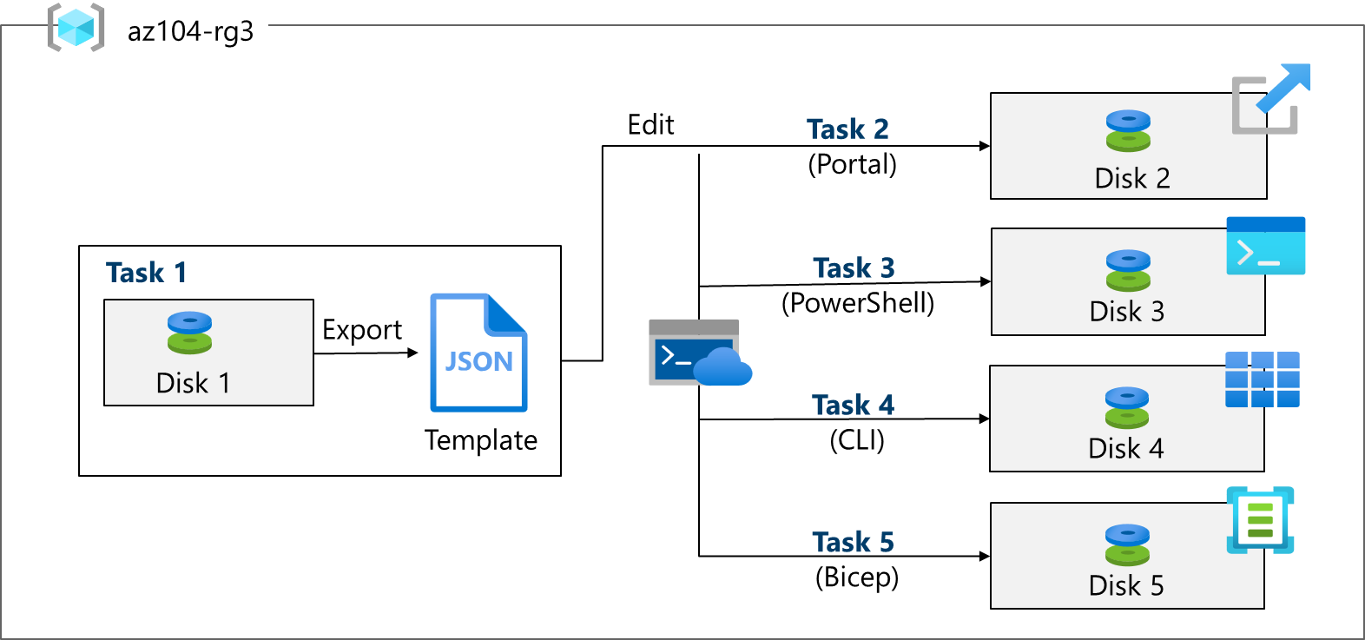

Job Skills Covered
- Create ARM templates
- Modify and redeploy templates
- Deploy templates using PowerShell
- Deploy templates using Azure CLI
- Deploy resources using Bicep

Task 1 – Create an ARM Template

Purpose
Create a resource manually and export it as an ARM template for reuse.

Steps
- Sign in to https://portal.azure.com
- Search for Disks
- Select Create

Managed Disk Configuration
Setting | Value
Resource Group | az104-rg3
Disk name | az104-disk1
Region | East US
Disk type | Standard HDD
Size | 32 GiB
Source | None

- Select Review + Create → Create
- After deployment, select Go to resource
- Select Automation → Export template
- Download and extract the ZIP file
Files Generated
- template.json
- parameters.json

Task 2 – Edit and Redeploy an ARM Template

Purpose
Reuse the exported template to deploy another resource.

Steps
- Search Deploy a custom template
- Select Build your own template
- Load template.json

Template Changes
- Rename parameter:
  - disks_az104_disk1_name → disk_name
- Change disk name:
  - az104-disk1 → az104-disk2
Save changes.

Parameter File Changes
- Rename parameter:
  - disks_az104_disk1_name → disk_name
Save changes.

Deploy Template
Setting | Value
Resource group | az104-rg3
Disk name | az104-disk2
Select Review + Create → Create

Verification
- Two disks exist: az104-disk1 and az104-disk2
- Review deployments under Resource Group → Deployments

Task 3 – Deploy Template Using Azure PowerShell

Purpose
Deploy ARM templates using Cloud Shell + PowerShell.

Steps
- Open Cloud Shell
- Select PowerShell
- Mount a storage account
- Upload template.json and parameters.json

Modify Template
- Change disk name to az104-disk3
- Save file

PowerShell Deployment Command
New-AzResourceGroupDeployment `
-ResourceGroupName az104-rg3 `
-TemplateFile template.json `
-TemplateParameterFile parameters.json

Verify Deployment
Get-AzDisk | ft

Task 4 – Deploy Template Using Azure CLI

Purpose
Deploy ARM templates using Azure CLI (Bash).

Steps
- Switch Cloud Shell to Bash
- Confirm files exist:
ls

Modify Template
- Change disk name to az104-disk4
- Save file

CLI Deployment Command
az deployment group create \
--resource-group az104-rg3 \
--template-file template.json \
--parameters parameters.json

Verify Deployment
az disk list --resource-group az104-rg3 --output table

Task 5 – Deploy Resource Using Azure Bicep

Purpose
Use Bicep, a modern alternative to ARM JSON.

Steps
- Upload azuredeploydisk.bicep to Cloud Shell
- Open the file in the editor

Modify Bicep File
Setting | Value
Disk name | az104-disk5
SKU | StandardSSD_LRS
Disk size | 32 GiB
Save changes.

Deploy Bicep Template
az deployment group create \
--resource-group az104-rg3 \
--template-file azuredeploydisk.bicep

Verify Deployment
az disk list --resource-group az104-rg3 --output table

Cleanup (Optional)

Portal
- Delete resource group az104-rg3

PowerShell
Remove-AzResourceGroup -Name az104-rg3

CLI
az group delete --name az104-rg3

